Carpe Diem Planner & Workbook
An opportunity to develop your skills and (re)design a great course - together

This planner provides an overview of the activities to be carried out over the one day session and the structure it will follow.

It is intended to guide you during the Carpe Diem Workshop session.

Carpe Diem is a team approach

Step 1: Please complete the table below
Participants | Role | Areas of education/  teaching | Expectations for the day
Dan Evans | CIO  Facilitator | Economics, Innovation, OB, Leadership,… | Get people excited about rapid course design and prototyping. Create great stuff.

Step 2: Get into work teams around a common work area
Participants | What course will you be working on today? What are your expectations in terms of design?
Dan Evans  Véronique Bouchard  Paul  John | Understanding the Strategic Business Environment. Looking to build a 100h ECTS course with only 24h of face-to-face activity (lecturing or small group activity coaching)

Facilitators

Carpe Diem workshop facilitators: XXXXX
Learning Technologist: XXXXX
Academic Liaison Librarian & Support: XXXXXX
Student representatives: XXXXXX
Quality Office Representative: XXXXXXX
Reality checkers: XXXXXXXX
Critical friends: (employers, service users, peers from other subject areas, externals…)

Carpe Diem Workshop Outline

Today’s outline

1. Write a blueprint
Here you work together to lay out the essential aspects of your course.

2. Make a storyboard
Here you draw out the process of your unit as a ‘storyboard’. You may do this on paper first, then online, using a tool such as Popplet, or NoteApp.

3. Peer Review
A final check of the design and feedback from peers

4. Build prototype components online (Blackboard)
Select key elements of your storyboard, including a few e-tivities and classroom activities where appropriate, and design them in your VLE.

5. Planning your next steps
Now the team is ready to build an action plan together to take the concept to reality

6. Reflect
What are key take-aways from the day ?

Future work

7. Finalize your prototype online
Add all componenets into the VLE

8. Check reality
Your designs are tried out by your reality checker, to see how they work. Check with past, current or future participants

9. Review and adjust
Building on the feedback from the reality checker, you review the work so far, make adjustments, refine timings, flag up places to return to, indicate what additional work is needed and who should be responsible for it.

Carpe Diem Planner

Stage 1 - Create a blueprint

1.1 Our mission is...
Agree on the overarching aims and intentions of your programme. Write a statement that captures those aims and intentions below (or copy it, if it already exists).

Ask yourself: what should potential students not possibly miss?

Example:

Strategic Management enables students to discover concepts and apply, step-by-step, the main tools of strategic analysis in order to learn to think in competitive terms, like executive leaders.

This course is for [who] to help them achieve [what]
in less than 25 words

ENTREPRENEURIAL PROJECT AND BUSINESS PLAN
Before revision
The objective of this course is to teach students to identify and analyze the main steps of the entrepreneurial process through a practical undertaking in the launch process of a new activity based on an entrepreneurial opportunity.From entrepreneurial alertness to business plan, this course insists on the implementation of innovative and original ideas. The proposed value creation of the studentsʼ projects is addressed to specifically identified stakeholders and is supported by a rigorous project management method to elaborate the business plan.
After revision

FINANCIAL ANALYSIS
Before Revision
The course aims at enhancing the understanding of financial statements, and to use them to assess the financial health of a company.
After revision

QUANTITATIVE FINANCE
Before revision
This course allows discovering new concepts and approaches in finance from a mathematical and statistical angle, showing how most financial
products originate from or rely on a quantitative basis.
After revision

PROJECT MANAGEMENT
Before Revision
This course provides an introduction to Project Management, which is now used not only to manage technical and business developments, but
also as a method of organizational change. The course focuses on the fundamental of project management, including the definition of project
objectives, structuring, risk analysis and planning.
After revision

STRATEGIC MANAGEMENT
Before Revision
The focus of this course is on strategic management and business policy formulation and implementation. Strategic management is that set of
managerial decisions and actions that determines competitiveness and the long-run performance of an organization.
During this class, students will have to elaborate on a concrete strategic issue in teams; the goal of this project is for students to apply strategicconcepts and methods to a concrete business situation. Indeed, students will notably have to perform the diagnosis of a concrete strategic issue,
identify strategic opportunities and threats, assess the capabilities possessed and needed by the company to tackle with the strategic issue,
define strategic recommendations, make operational choices for implementing these recommendations, and assess the feasibility of these
recommendations.
After Revision

1.2 The learner

Understanding the leaner and the learner’s motivation is a critical first step when designing a course. Work collaboratively to complete the following questions about the learner.

Who is the learner?
>
>
>

How does the person feel about the learning to be done?
>
>
>
>

What are (according to you) the person’s attitudes about learning in general?
>
>
>
>
>

What does the person potentially see in the proposed course? Benefits? Costs?
BENEFITS  >  >  >  > | COSTS  >  >  >  >

To what degree are required soft and critical learning skills mastered ?
Skill | Mastery

How does the person typically learn?
>
>
>
>
>

How does the person typically behave when faced with new challenges?
>
>
>
>
>
>

What motivates or enables the person to learn?
>
>
>
>
>
>

What demotivates or disables the person to learn?
>
>
>
>
>
>
>

1.3 The ‘look and feel’ of your course

Use the course features cards provided, to choose the key features of your course. Sort the cards into three piles:

things you definitely want in your course | things you're not sure about | and things you definitely don't want

Then pick your top 6 cards: the non-negotiable ones. We will refer back to these as we’re building, to make sure we stay on track.
Orange=Guidance and Support, Blue=Content and Experience, Green=Communication and Collaboration, Purple=Reflection and Demonstration.

Take a photo of your selection and add it here:

Here is an example :
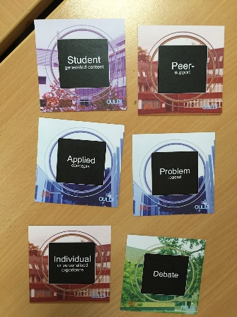

1.4 Learning outcomes

The next step is to review the learning outcomes for the course. If you already have these in your course specification or syllabus, copy and paste them in below.

We will check these as a team for:
- Sense (are they clear to the learner?)
- Level (are they appropriate to the level of the module?)
- Assess-ability (is it clear how the learner will be able to demonstrate achievement?)

Course learning outcomes

Example : Macroeconomics By the end of this course, you will be able to…

Knowledge
- Identify the key drivers of macroeconomic activity.
- Explain how various macroeconomic forces inter-act in a particular situation
- Express the macroeconomic risks and opportunities facing business
- Interpret economic data reported in the press and specialized economic organisations
- Explain economic forecasts published by recognized economic organisations
Specific skills
- Identify sources of economic information and read macroeconomic data for different countries and economic zones
- Collectively debate and evaluate the relevance, pertinence and robustness of macroeconomic data and their sources
- Forecast economic growth and interest rates
- Build a dashboard of main macroeconomic indicators
- Apply the IS-LM and AD-AS models
- Critically evaluate and appraise published forecasts individually and in teams
Key skills (soft)
- Make decisions in small teams
- Prepare a dossier in teams
- Use relevant internet sources for economic analysis
- Work via electronic forums

You can refer to the list of ACTION verbs provided in the following pages.
Remember, our outcomes need to be MEASUREABLE.

Start at the End and Proceed to the Beginning
Good design always starts with a good understanding of the desired result. As educators our goal is to develop and deepen student understanding. In order to design learning experiences and opportunities for our students, we need to articulate the specific learning goals--the knowledge, skills, understandings and traits--they will need to be successful professionals and citizens.Program and course outcomes should drive the design of activities and assessments within the classroom.

Huba, M.E. & Freed, J.E. (2000). Learner-centered assessment on college campuses: Shifting the focus from teaching to learning (Links to an external site.). Needham Heights, MA: Allyn & Bacon. (p. 108).

Here are the course outcomes as defined in Tomorrow. If these already exist, copy and paste them into the appropriate spaces. Review and adjust

Course Title | Entrepreneurial Project and Business Plan
Outcomes and Objectives pre-defined | The concepts covered are particularly those associated with entrepreneurial processes (entrepreneurial opportunity, innovation, pretotyping, lean startup methodology, Business Model, executive summary, pitch)  Identify an entrepreneurial opportunity  Prototype and test an innovative solution  Evaluate and report the economic feasibility of the project  Communicate strategically about the project  Craft a business plan and budget up to market launch
Knowledge and
Understanding
Subject Specific
Skills
Key Skills

Course Title | Financial Analysis
Outcomes and Objectives pre-defined | Gain a comprehensive overview of accounting statements needed for financial analysis  Understand and become skillful in using ratios;  Develop critical thinking about financial statements in relation to the strategy formulated by the firm.
Knowledge and Understanding
Subject Specific Skills
Key Skills

Course Title | Quantitative Finance
Outcomes and Objectives pre-defined | Quantitative finance offers a conceptual framework and mathematical tools to understand a complex and changing financial world.  The concepts and mathematical tools will be illustrated with examples and applications. A practical presentation of the main statistical and  mathematical tools in Excel will also be discussed and practiced.  Understanding the mathematical tools  Using the appropriated tools in a specific context
Knowledge and Understanding
Subject Specific Skills
Key Skills

Course Title | Project Management
Outcomes and Objectives pre-defined | The concepts covered include project management techniques, such as structuring, planning, risk analysis, project monitoring and control.  At the end of this course, students will be able to develop a project development plan and understand its implications for the organization. They will also get technical expertise through the use of MS Project.
Knowledge and Understanding
Subject Specific Skills
Key Skills

Course Title | Strategic Management
Outcomes and Objectives pre-defined | To understand strategic issues and policy decisions facing businesses and how current thinking addresses these issues.  To understand why some firms succeed and others fail.  To improve analytical ability in assessing strategies and policies that determines the long-term success of firms.  To have the ability to analyze internal organizational strengths and weaknesses and external environmental opportunities and threats.  To provide opportunities for every student to participate in relevant discussions of strategic issues.
Knowledge and Understanding
Subject Specific Skills
Key Skills

Deep Dive 1: Writing Learning Outcomes

When writing course outcomes, focus on the important aspects of the discipline or course subject, use action verbs and be realistic about what students achieve. Outcomes should describe what the student can do by the end of the course. Take advantage of your knowledge of the key abilities professionals in the field need to be successful. Collaborate with colleagues who are expert in the discipline and are also experienced teachers. Bounce your ideas off of the instructional designers and other workshop particiapnts.

This grid, created by the assessment professionals at University of Hawai'i at Manoa provides a clear visualization of the building blocks for developing learning outcomes:

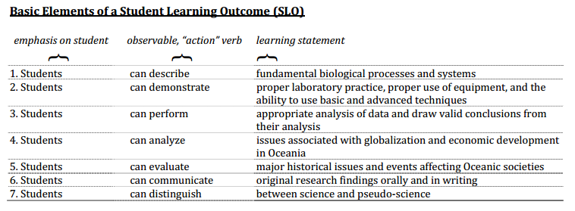

Some things to remember:

- Focus on the student--what the student will be able to do by the end of the course or program.
- Describe outcomes, not processes or activities.
- Start each outcome with an action verb.
- Use only one action verb per learning outcome.
- Avoid vague verbs such as know and understand.
- Check that the verbs used reflect the level of learning required (see Bloom)
- Ensure that outcomes are observable and measurable.
- Write the outcomes in terms of what the learner does, not what the instructor does.
- Check that the outcomes reflect knowledge, skills or attitudes required in the workplace or the wider community.
- Check that there is an appropriate number of outcomes.
- Check that course and program outcomes align with School competencies

Poor : Students should know the historically important systems of psychology.
Better : Students should understand the psychoanalytic, Gestalt, behaviorist, humanistic, and cognitive
approaches to psychology.
Best : Students should be able to recognize and articulate the foundational assumptions, central
ideas, and dominant criticisms of the psychoanalytic, Gestalt, behaviorist, humanistic, and
cognitive approaches to psychology.

Bloom’s Taxonomy

Level | Verbs which describe the activity to be trained or measured at each level | Examples of activity to be trained, or  demonstration and evidence to be measured
Remembering  Recall or recognize information | Arrange, define, describe, label, list,  memorize, recognize, relate,  reproduce, select, state | Multiple-choice test, recount facts or statistics, recall a  process, rules, definitions; quote law or procedure
Understanding  Understand meaning, re-state data in one's own words,interpret, extrapolate, translate | Explain, reiterate, reword, critique, classify, summarize, illustrate, translate, review, report, discuss, re-write, estimate, interpret, theorize, paraphrase, reference, example | Explain or interpret meaning from a given scenario or statement, suggest treatment, reaction or solution to  given problem, create examples or metaphors
Applying  Use or apply knowledge, put theory into practice, use knowledge in response to real  circumstances | Use, apply, discover, manage,  execute, solve, produce, implement, construct, change, prepare, conduct, perform, react, respond, role-play | Put a theory into practical effect, demonstrate, solve a problem, manage an activity
Analyzing  Interpret elements, organizational  principles, structure, construction, internal relationships; quality, reliability of individual  components | Analyze, break down, catalogue,  compare, quantify, measure, test,  examine, experiment, relate, graph,  diagram, plot, extrapolate, value,  divide | Identify constituent parts and functions of a process or  concept, or de-construct a methodology or process,  making qualitative assessment of elements, relationships, values and effects; measure requirements or needs
Evaluating  Assess effectiveness of whole concepts, in relation to values,  outputs, efficacy, viability; critical  thinking, strategic comparison and review; judgment relating to  external criteria | Review, justify, assess, present a  case for, defend, report on,  investigate, direct, appraise, argue,  project-manage | Review strategic options or plans in terms of efficacy, return on investment or cost-effectiveness,  practicability; assess sustainability; perform a SWOT analysis in relation to alternatives; produce a financial  justification for a proposition or venture, calculate the effects of a plan or strategy; perform a detailed risk analysis with recommendations and justifications
Creating  Develop new unique structures, systems, models, approaches,  ideas; creative thinking,  operations | Develop, plan, build, create, design, organize, revise, formulate, propose, establish, assemble, integrate, re-arrange, modify | Develop plans or procedures, design solutions, integrate methods, resources, ideas, parts; create  teams or new approaches, write protocols & contingencies

1.5 Assessment Strategy

Assessment can be contentious but do your best to think differently about it. If you start creatively with assessment, designing uncommon, non-traditional approaches for learning come a little easier.

To start you thinking about your assessment tasks, record your answers in the tables below. For the moment, keep it “high level”. What does assessment look like in your course in general? What is your “assessment strategy”?

For each entry brainstorm various options. Note all ideas.

Course Title | Entrepreneurial Project and Business Plan
What must be summatively assessed?
How can you reduce marking and increase feedback?
What summative assessment methods are appropriate for the course?
How can learning be formatively assessed
Ways to encourage peer feedback
We will exploit technology for assessment increasing fairness and speed?

Course Title | Financial Analysis
What must be summatively assessed?
How can you reduce marking and increase feedback?
What summative assessment methods are appropriate for the course?
How can learning be formatively assessed
Ways to encourage peer feedback
We will exploit technology for assessment increasing fairness and speed?

Course Title | Quantitative Finance
What must be summatively assessed?
How can you reduce marking and increase feedback?
What summative assessment methods are appropriate for the course?
How can learning be formatively assessed
Ways to encourage peer feedback
We will exploit technology for assessment increasing fairness and speed?

Course Title | Project Management
What must be summatively assessed?
How can you reduce marking and increase feedback?
What summative assessment methods are appropriate for the course?
How can we formatively assess learning
Ways to encourage peer feedback
We will exploit technology for assessment increasing fairness and speed?

Course Title | Strategic Management
What must be summatively assessed?
How can you reduce marking and increase feedback?
What summative assessment methods are appropriate for the course?
How can we formatively assess learning
Ways to encourage peer feedback
We will exploit technology for assessment increasing fairness and speed?

Deep Dive 2: Designing Assessments

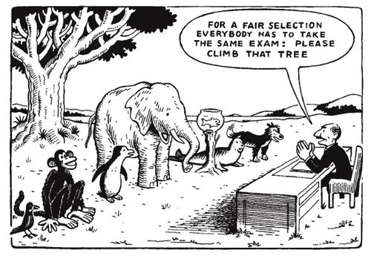

As you design assessment think about some key tips for effective and ineffective assessment

Effective | Ineffective
Large number of regular tasks or assignments (or smaller number of large and complex assignments) that generate sufficient effort and distribute that effort across topics.  Most assignments as course requirements, without marks.  Regular cycles of feedback and practice involving a limited range of types of assignment.  Less reliance on teachers for feedback and more involvement of students. | Too much summative assessment for marks and too little formative assessment, for learning.  Trivial assignments that make low intellectual demands  Too much variety in forms of assignment, causing:

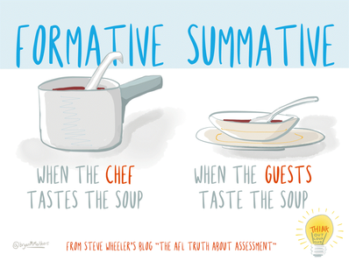
Formative Assessment :
- Help students to learn and practice
- Done throughout the course
- Helps identify gaps and improve learning
- Supports specific needs of students
- Based on effective feedback principles
- Should not demand significant time

Summative Assessment
- Assess student performance
- Typically done at the end of the course
- Collects evidence of knowledge and proficiency
- Requires time from students and faculty

Formative Assessment Examples | Summative Assessment Examples
- Question and answer sessions, both formal - planned and informal - spontaneous  - Conferences between the instructor and student at various points in the semester  - In-class activities where students informally present their results  - Student feedback collected by periodically answering specific question about the instruction and their self-evaluation of performance and progress  - Peer feedback of written work, ideas  - Online quiz to check understanding  - Observations during in-class activities; of students non-verbal feedback during lecture  - Homework exercises as review for exams and class discussions  - Reflections journals or e-portfolio reflections that are reviewed periodically during the semester | - Examinations (major, high-stakes exams)  - Term papers (drafts submitted throughout the semester would be a formative assessment)  - Projects (project phases submitted at various completion points could be formatively assessed)  - Portfolios (could also be assessed during it’s development as a formative assessment)  - Presentations  - Practical Assessment  - Journals/ Blogs/ Wikis (can also be formative)  - Academic Posters  - Conference Proceedings  - Papers  - Case Studies  - Reports

Don’t forget about CATs (Classroom Assessment Techniques)

- The Background Knowledge Probe is a short, simple questionnaire given to students at the start of a course, or before the introduction of a new unit, lesson or topic. It is designed to uncover students’ pre-conceptions.
- The Minute Paper tests how students are gaining knowledge, or not. The instructor ends class by asking students to write a brief response to the following questions: “What was the most important thing you learned during this class?” and “What important question remains unanswered?”
- The Muddiest Point is one of the simplest CATs to help assess where students are having difficulties. The technique consists of asking students to jot down a quick response to one question: “What was the muddiest point in [the lecture, discussion, homework assignment, film, etc.]?” The term “muddiest” means “most unclear” or “most confusing.”
- The What’s the Principle? CAT is useful in courses requiring problem-solving. After students figure out what type of problem they are dealing with, they often must decide what principle(s) to apply in order to solve the problem. This CAT provides students with a few problems and asks them to state the principle that best applies to each problem.
- Defining Features Matrix: Prepare a handout with a matrix of three columns and several rows. At the top of the first two columns, list two distinct concepts that have potentially confusing similarities (e.g. hurricanes vs. tornados, Picasso vs. Matisse). In the third column, list the important characteristics of both concepts in no particular order. Give your students the handout and have them use the matrix to identify which characteristics belong to each of the two concepts. Collect their responses, and you’ll quickly find out which characteristics are giving your students the most trouble.
- Chain Notes: Students pass around an envelope on which the teacher has written one question about the class. When the envelope reaches a student he/she spends a moment to respond to the question and then places the response in the envelope. Go through the student responses and determine the best criteria for categorizing the data with the goal of detecting response patterns. Discussing the patterns of responses with students can lead to better teaching and learning.
- Directed Paraphasing: Ask students to write a layman’s "translation" of something they have just learned -- geared to a specified individual or audience -- to assess their ability to comprehend and transfer concepts. Categorize student responses according to characteristics you feel are important. Analyze the responses both within and across categories, noting ways you could address student needs.
- One sentence summary (tweet summary): Students summarize knowledge of a topic by constructing a single sentence that answers the questions "Who does what to whom, when, where, how, and why?" The purpose is to require students to select only the defining features of an idea. Evaluate the quality of each summary quickly and holistically. Note whether students have identified the essential concepts of the class topic and their interrelationships. Share your observations with your students.
- Student Generated Test Questions: Allow students to write test questions and model answers for specified topics, in a format consistent with course exams. This will give students the opportunity to evaluate the course topics, reflect on what they understand, and what are good test items. Make a rough tally of the questions your students propose and the topics that they cover. Evaluate the questions and use the goods ones as prompts for discussion. You may also want to revise the questions and use them on the upcoming exam

1.5 Now it’s time to show alignment!

List the assessment activities you have chosen, and detail how each assessment aligns with the specified learning outcomes - which outcomes are you assessing? Is the task appropriate to assess these?

Then start thinking about the learning and teaching activities you will need to help students achieve those outcomes. This process is known as “constructive alignment”. For more on this, see Biggs (2003).

Entrepreneurial Project and Business Plan
Learning Outcomes | Assessment Activities | Possible Learning Activities

Financial Analysis
Learning Outcomes | Assessment Activities | Possible Learning Activities

Quantitative Finance
Learning Outcomes | Assessment Activities | Possible Learning Activities

Project Management
Learning Outcomes | Assessment Activities | Possible Learning Activities

Strategic Management
Learning Outcomes | Assessment Activities | Possible Learning Activities

Stage 2 - Storyboard

All the resources that you now have around you form a blueprint (your mission, your assessment plans, the look and feel of your course,) but you need to create a process of integration and flow. You can do this by ‘storyboarding’.

Storyboarding means visually representing a process that you can later build. It needs to show what the key players do, how they move through the process, what the critical moments are in the ‘story’ and of course what it’s all leading to and what happens in the end.
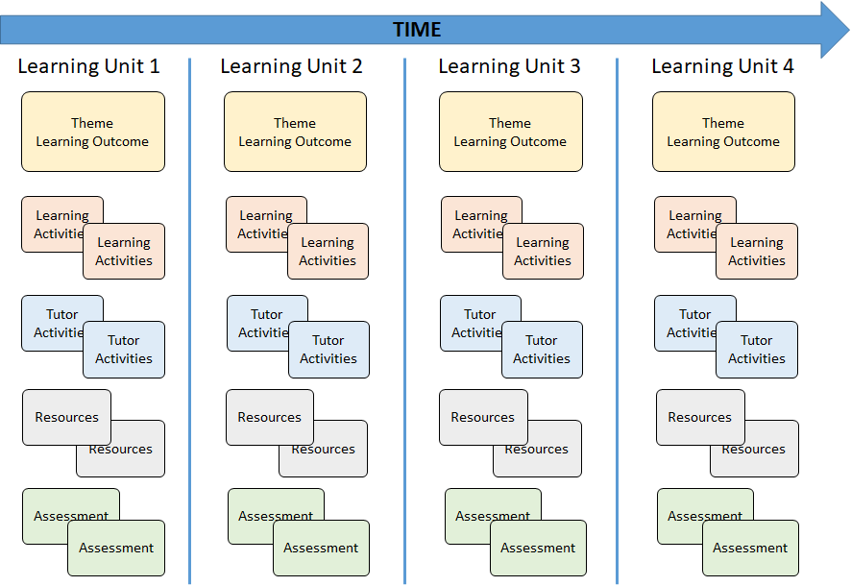

You don’t need to get into the nitty gritty details at this stage. Think more about sequencing and progression - the Five Stage model might help you here. You might also want to start thinking about the best use of contact time (if you have it). If you have activities or resources that you know work well, make a note of them. We’ll build them into structured learning activities later on.

When your storyboard is complete, you may want to transfer it to a visual online tool such as Popplet. This helps you keep a copy (without the Post-its falling off!) and can also act as a helpful visual course map for students if you upload it in to the learning environment.
Alignment of Activities (e-tivities)
Alignment of activities is both horizontal and vertical
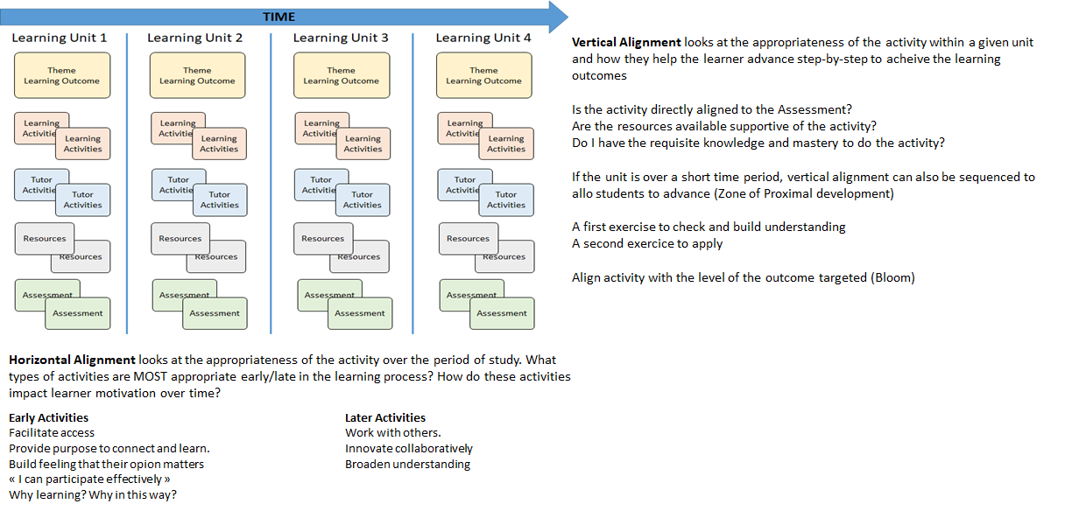

Horizontal alignment uses the 5 stage model of learner maturity progression
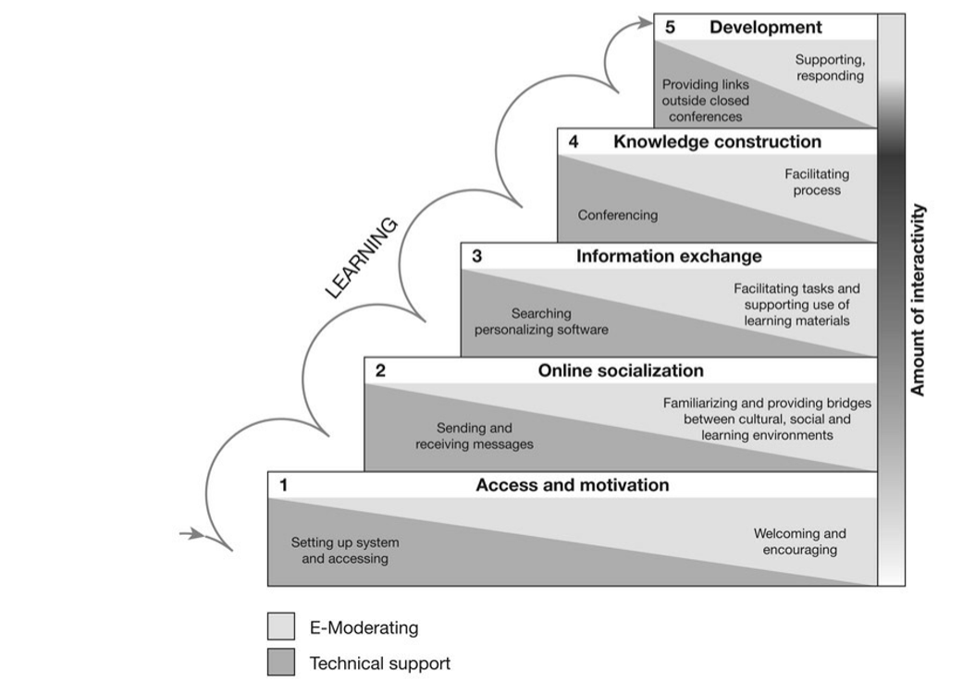
Example
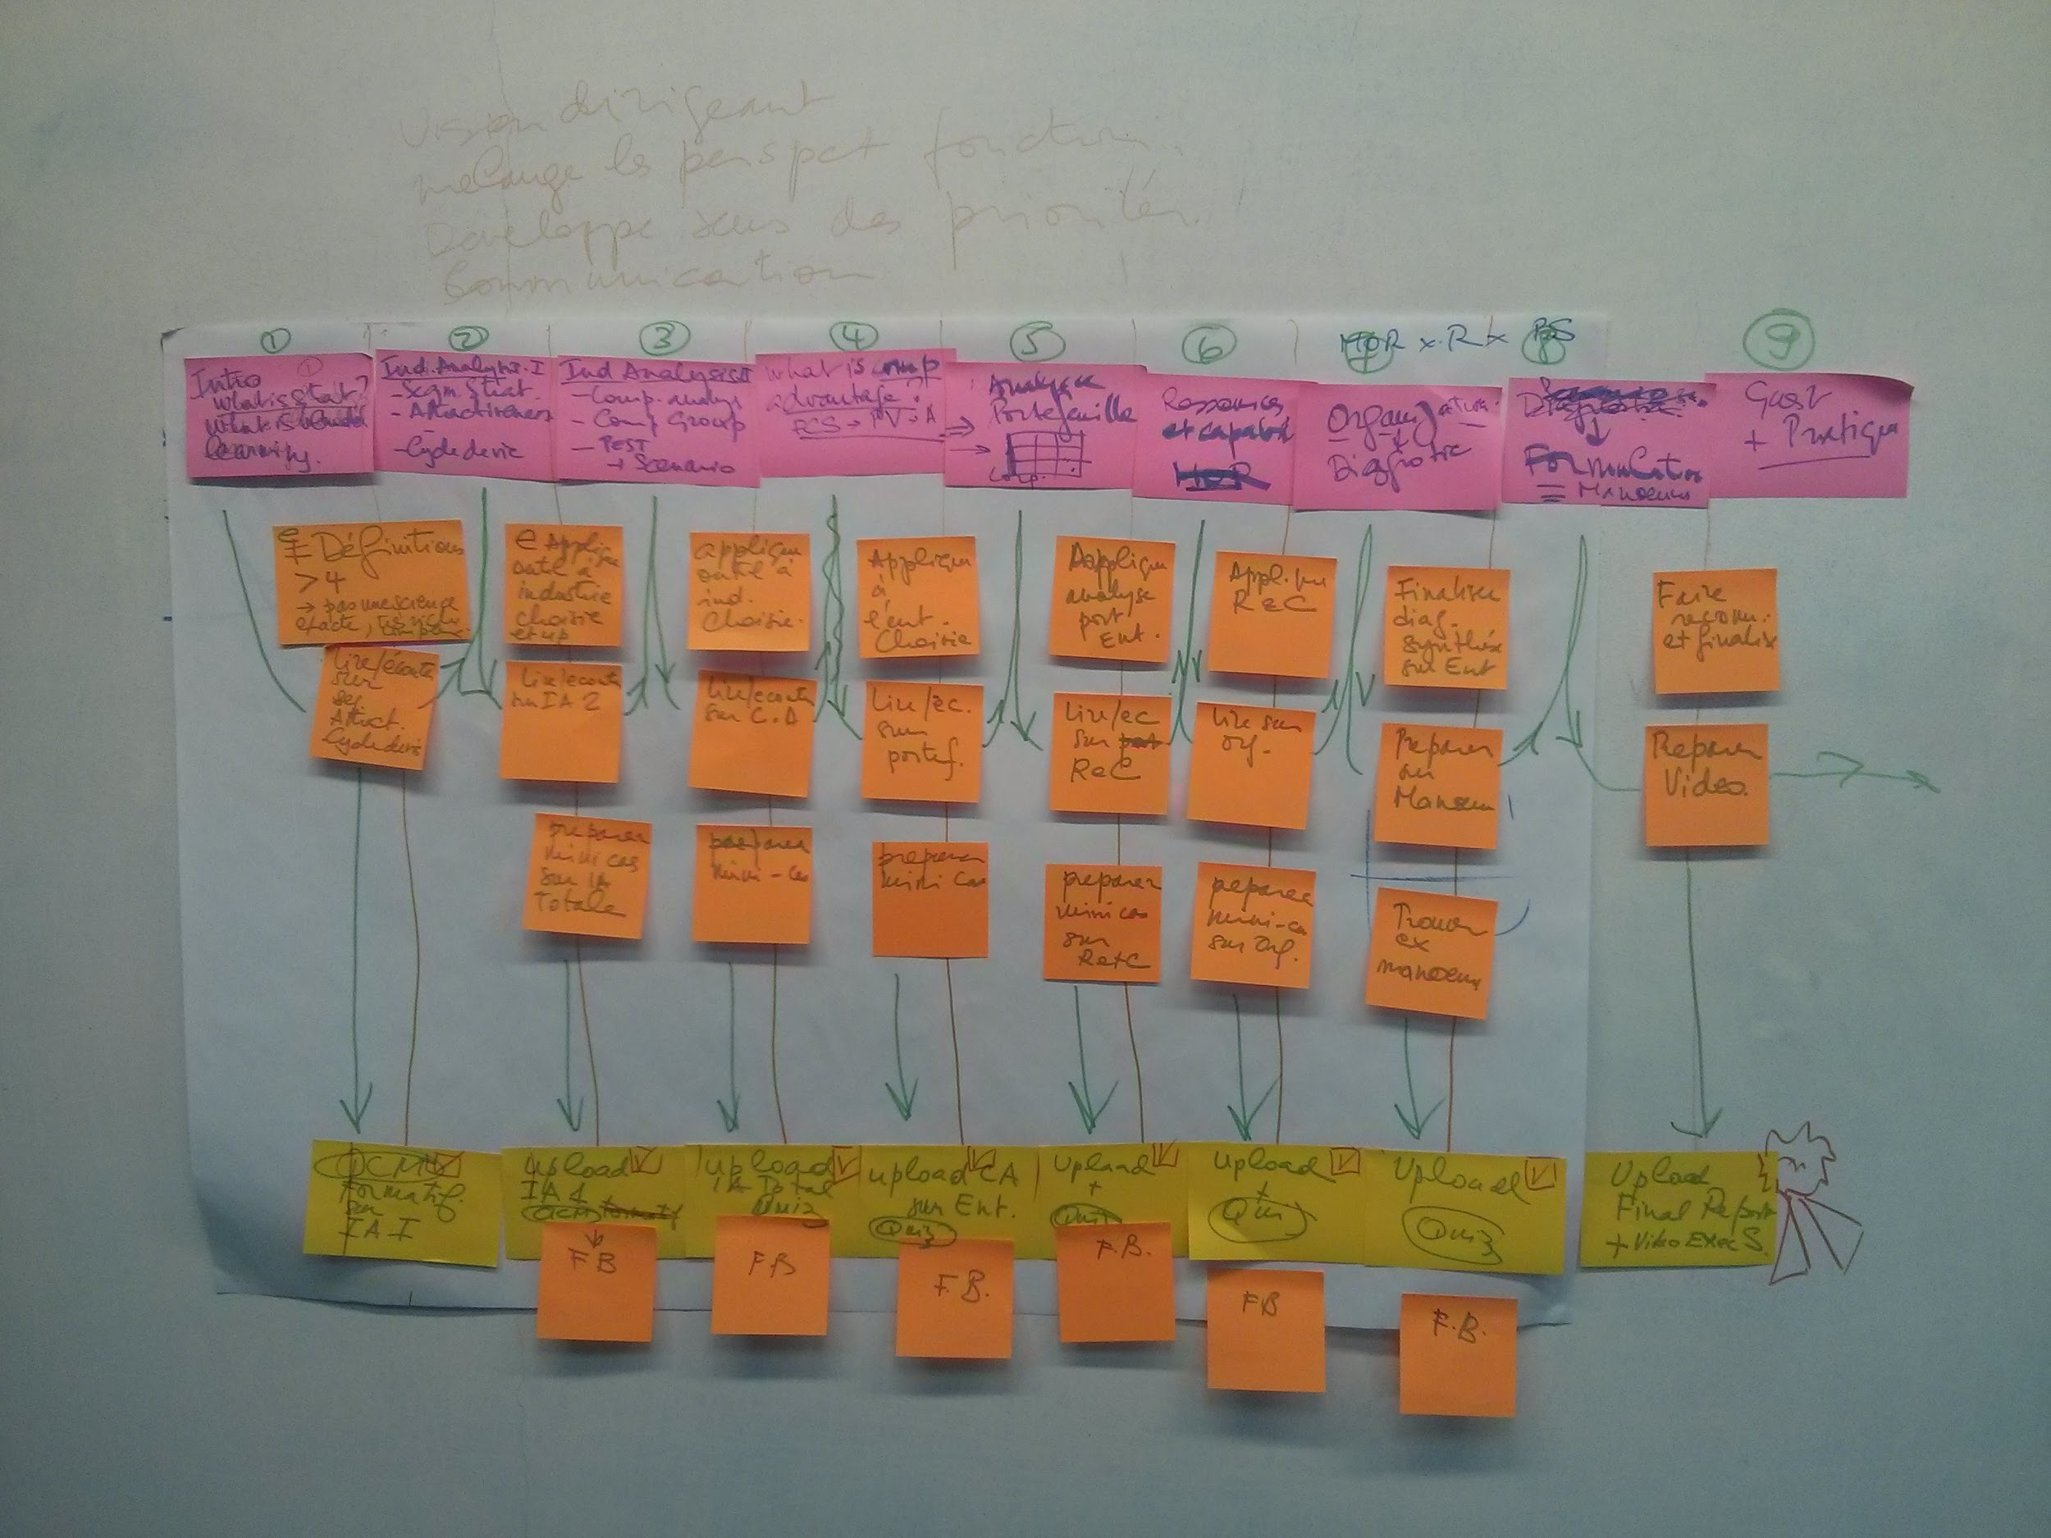

Stage 3 - Build

3.1 Designing learning activities
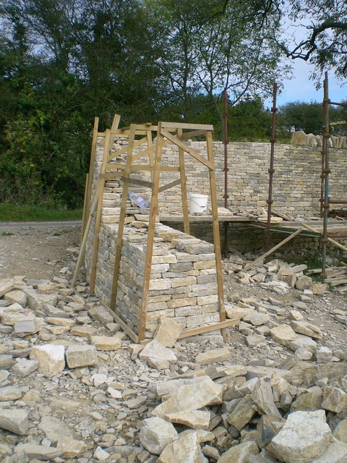
In this stage we will start constructing the learning activities that will enable your students to achieve the outcomes and succeed in the assessments. Choose one learning activity at a time from your storyboard, and develop it in more detail using the guidelines below.

If you’ve taught this course or module before in a different mode, you may find it useful to reflect on learning activities that have worked well for your outcomes, as well as those that haven’t worked as well. Some of this good practice may be translated to the online environment.

It’s helpful at this stage to keep your audience in mind. If your learners have varying levels of previous knowledge and experience, or the module in question is taught across a range of programmes, you may need more than one activity for each outcome to make it relevant and engaging for all your learners. Diagnostic or self-assessment activities early on can help you adjust and target these activities appropriately.

Deep Dive 3: Learning Activities

Learning activities can take place in or out of the classroom. Below you will find some ideas for structuring activities in a range of contexts. All of these models use Principles of Good Practice, which you may find helpful to review when creating and reviewing activities.

Listening to lectures for long periods doesn’t stimulate mental engagement, whether they are live or recorded. Good learning activities will involve some action on the part of the learner. Have a look at some of these resources on active learning to get you started.

Stuck for ideas for good activities?
These Viewpoints cards can help you think about the different types of task that can support learning. They also include some suggestions for tools to use.
This free online book has lots of examples of learning activities you could try out.
(UK PSF A1, A2, A4)

3.2 Activities and learner “readiness”

Activities are designed with the learning outcome and the learner abilities/motivation in mind. As learners become more comfortable with online learning new WAYS of learning can be addressed. Early on, activities are used to build confidence and increase learner motivation.

Here are some typical activities for each stage

Stage 1 | Icebreakers  Quiz about the learning group  Discovery of learning styles  Share images about self/life  Analyzing web sites of companies  Where would you invest 1M€ (look at best practices of companies, perception of learner)  Concept mapping  Explore nature of success of the course  Build a “learner code of conduct”  Relate a concept to something you see  Create a skills and knowledge market – who can help others with what?  Share your tech tips; study tips
Stage 2 | Describe self in 6 words  “If” questions  Explore cultural differences and similarities  Scenario based discussion and sharing of investigative questions  Insight thinking problems  Enigma resolution as a group
Stage 3 | Start a repository of great online videos – everyone contribute your favorite  Condense famous speeches into X words  Practice summarizing information  Think-pair-share exercise  Explore trends  Investigate past failures  Explore big data on a particular subject  Debates  Delphi techniques  Nominal group techniques (voting)  Collaborative brainstorming  Post intriguing open questions (insight) (what does the word success mean in business?)  What if..questions (what if the world ran out of ….)
Stage 4 | Structured teamwork activities  Diagram concepts  Demonstrate how a key concept applies to particular case  Case studies  Challenging problems that have a variety of solutions (amibuiguity)  Build actions plans  Summarizing activities
Stage 5 | Review of learning generated and what drove the learning  Review past messages and how they would be changed  Personal development plans  What insight , knowledge would you share with future students

3.2 Creating learning activities

Look at your storyboard again. Pick out some activities (the green sticky notes). Take one learning activity per pair or group and draft it out on paper using the headings in the template below.

When you have an activity that you think may work, move to the computer. Each pair builds one activity directly online in the NILE site, returning to the storyboard to adjust as necessary. Put as much as you can in but do it fairly quickly. Put links to URLs for sparks if possible. Try and make it as ‘user-ready’ as possible.

Insert a clear marker in the NILE site page (such as a holding image or coloured alert text) where you need to return later or ask for further technical help, e.g. to insert an interactive diagram.

As soon as an activity looks usable, move onto another one.

Activity Template
Activity Name and Stage (5 stage model)
Image/fact/controversial statement to attract
Suggested activity time and complexity of the activity
Purpose (WIIFM)
Task – resources, how resources are engaged/used – what is done WITH the resource (not passive!)
Reflection and Feedback

NOTE : what are the technical possibilities of the VLE ? To integrate somehow.

E-tivities

Usually used for online learning activities, but can work for classroom planning too. This template helps ensure that online work is not simply about accessing content, but about actively constructing understanding. Works well in blended and online courses.

The template below is a short version of this model, a more detailed version is available on Gilly Salmon’s website.

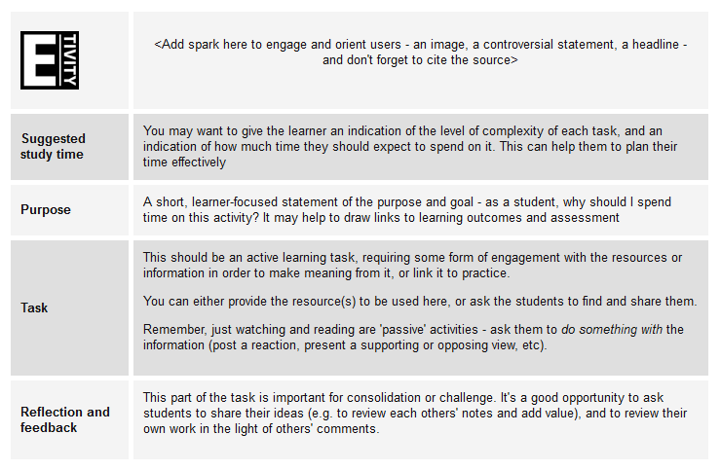

3.3 Tips for creating learning activities (with some help from Covey, 1990):

1. Begin with the End in Mind  What do you want to achieve by this activity?  How will it add to the students’ learning?  How will you evaluate the activity?  2. First Things First!  How will you introduce and start the activity off?  How much notice will the students need?  Can you design clear instructions?  3. Think Win : Win  Why will the students want to take part?  Will it add obvious and clear value? | 4. Sharpen the Saw  How will you prepare yourself to make this activity a success?  What pre-requisite skills or knowledge are needed to complete the task successfully?  5. Be Proactive  Plan your role and actions.  How often will you need to intervene?  What will you do about non-participants?  6. Seek to Understand  What happens if the activity doesn’t go as you planned?  How can you get information to change it for next time?

Stage 4 - Check reality
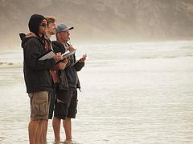
Ask your students, colleagues, peers, and managers to come and help you for an hour or two. It’s useful if people know something about the topic but they do not have to be experts. Actually it’s better if they are not. They will be your ‘critical friends’.

Ensure that by the time the reality checkers arrive (plan for around lunchtime on Day 2 – food seems to help), you have some e-tivities ready for them to try out. Depending on how many e- tivities you have designed, you may need to allow up to an hour. Ask the reality checkers to make notes on a form which has some basic guidance and they can leave with you.

Sit out of their way but be available in case they need technical help. Do not interrupt or intervene. If they ask for help, offer enough to get them started again. Do not enter into explanations but encourage them to work online and autonomously as much as possible.

It’s a good time for the Carpe Diem team to take time out, and return to discussing any contentious issues or reflect and review on what they have learnt.

Then ask the reality checkers to give direct feedback to the team based on their experience of trying out the e-tivities. Ask them questions by all means – but try and listen and not get defensive. Ask them to leave their notes with you.

Reality checker’s form:

Topic, unit or module | Learning activity number or name

Note: you do not have to complete the task itself, instead, assess it from a student’s point of view.

First impressions

How easy is the activity to navigate?

Is it clear what you are supposed to do? Describe any issues

List two of the features of the activity you found enjoyable and/or effective

How would you improve the activity?

Overall comments

Stage 5 - Review and adjust

The reality checkers have left the building.

As a team, list your reality checker’s main concerns and suggestions. Talk through the impact
of these comments. Decide whether you need to:
- Rethink any of the components of your blueprint
- Adjust your storyboard, especially consider navigation, timings and assessment
- Work on immediate improvements to the e-tivities

Take the actions you can immediately but also start to consider next steps. Before you move on, just make sure you are in a different and better place with your course than when you started (if not, why not?) on the morning of Day 1.

Stage 6 - Plan your next steps

6.1 Create a clear timeline

- on the right hand side mark the actual date when the unit/course/module will be delivered to students
- on the left is today’s date
- mark out some calendar divisions – you can do this in days or weeks, or even months. (no years are allowed!)
- now mark off critical days and events along the way
- make it look as attractive and do-able as possible
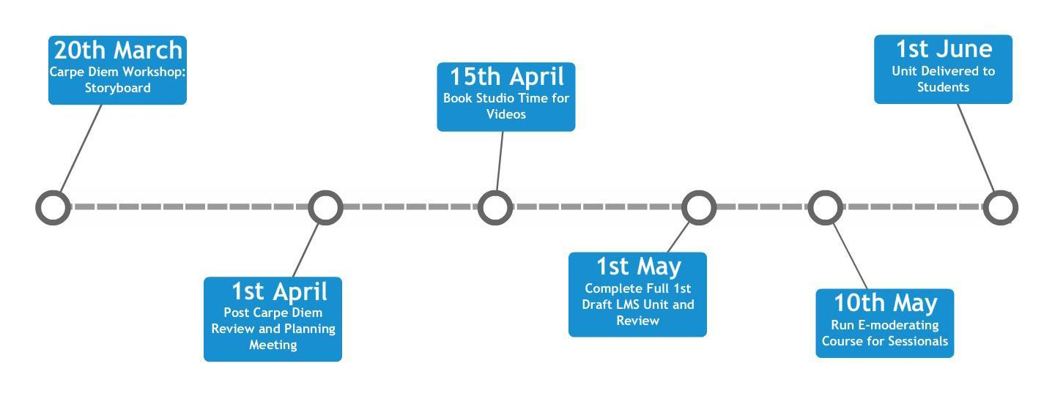

6.2 Start your Action Plan

You need another big flip chart or white board (or wiki or Google docs) divided up into

- What else needs doing and who will do it?
- Assess the risks (how are you going to find the time to complete the work, what might interfere, who else might need to be involved).
- Consider what other resources or people you need to consult acquire or include, as well as resources that you had available but did not use.
- Set clear deadlines.
- Set a date for your next team meeting when you will review progress.
- What post-Carpe Diem follow-up would be useful? e.g. Identifying and training your e-moderators.

Example action plan:

Tasks | Name(s) | Help needed and sources of help | Risks | Completion date
[e.g.] At least 2 more e-tivities in unit 3. | Ale | IT coordinator (may require multimedia element). | IT coordinator on holiday last week in Feb. | End of March

Please take your blueprint, storyboard and action plan with you.

6.3 Follow up (2-6 weeks later)

A follow-up meeting between the Carpe Diem team and the unit or module members who participated in the workshop (including their Learning Technologists and Subject Librarians) to talk through plans, revise previous e-tivities, develop new ones and discuss other design issues.

- Check progress on the action plan, especially consider timescales and deadlines
- Plan further actions not originally thought of - don’t forget addressing quality learning issues and plans to disseminate your achievements.
- Discuss any problems with the storyboard, technology availability revise e-tivities and develop new ones and discuss other design issues.
- Make sure you have sufficient technology support to help implement the design.
- Consider a short E-Moderating online course to develop delivery skills.
- Share what you’ve learnt from each other, decide who else to tell...Celebrate.

Stage 7: Reflect

7.1 How has this process developed your skills?

Throughout the Carpe Diem you will have developed your programme design skills, and considered a number of factors affecting both your teaching and the learner experience. You may want to make some notes on what you’ve learned while these are fresh in your mind. These could feed in to your personal development, as well as University quality assurance process documentation (such as validation proposals and PSR evaluation forms).

The UK Professional Standards Framework dimensions are provided here for reference - how many of these dimensions have you worked on in the Carpe Diem?

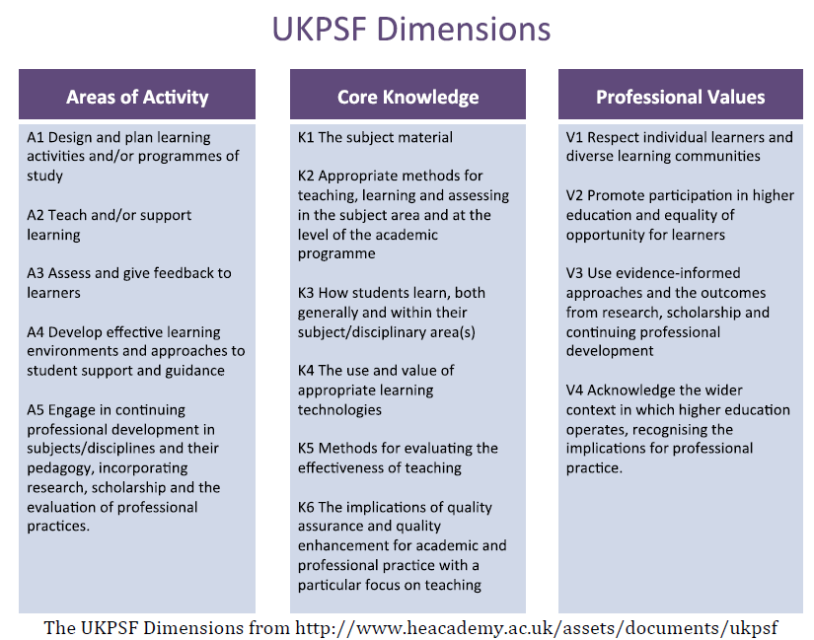

7.2 How could you implement this learning in your future practice?

Participation in L&T CPD | Date | Led by | Key Learning gained & links to UKPSF | Implementation & Extension | Further action planned
e.g. Carpe Diem for the Masters in Integrated Urbanism | June 2013 | SB & AA | - New appreciation of the need to plan for student LEARNING rather than concentrating on the design of teaching. (A1)  - New strategies for planning for OL/BL delivery (K2, K4) | Implementation of activities developed on the Carpe Diem in 13/14 Sem 1.  Planning for later module undertaken using Carpe Diem storyboard & eTivity structure | Obtain student evaluation of new approach to BL  Arrange peer observation with focus on my management of online discussion.  Obtain support to rollout Carpe Diem process with 2 dept UGrad progs

References and further reading

Biggs, J.B. (2003) Teaching for Quality Learning at University. 2nd edn. Buckingham: Open University Press.

Chickering, A.W., and Gamson, Z.F. (1987). Seven principles for good practice in undergraduate education. AAHE Bulletin, 39(7), 3-7.

Covey, S.R. (1990) The 7 habits of highly effective people: powerful lessons in personal change. Simon & Schuster: New York.

Wiggins, G. and McTighe, J. (2005) Understanding by Design. Expanded 2nd edition. Pearson: Upper Saddle Rivers, N.J.

Image credits:

Day 1 Stage 1 (blueprint)
Frates, T. (2014). Sky path; trail’s end. Flickr [online]. Available from: https://www.flickr.com/photos/54551481@N08/15583464595

Day 1 Stage 2 (storyboarding)
Green, T. (2010). Stepping Stones 2. Flickr [online]. Available from: https://flic.kr/p/8pgcFu

Day 2 Stage 3 (building prototypes)
Czapski, S. (2009). Building a dry stone wall, Dorset. Geograph [online]. Available from: http://www.geograph.org.uk/photo/2176416

Day 2 Stage 4 (reality check)
powelli. (2013). Official clipboard carriers. Flickr [online]. Available from: https://www.flickr.com/photos/31310680@N04/10319040365/

Deep Dives:
simplesolutiontech07. (2007). Blue Man Bending Over to Inspect Something Through a Magnifying Glass Clipart Illustration. Flickr [online]. Available from: https://www.flickr.com/photos/simplesolutiontech/4430990219/in/gallery-58987228@N04-72157625953507018/

Further Reading:

Salmon, G. (2011). E-moderating (3rd Edition). New York: Routledge. www.e-moderating.com

Armellini, A., & Aiyegbayo, O. (2010). Learning design and assessment with e-tivities. British Journal of Educational Technology 41(6), 922-935.

Armellini, A., Salmon, G., & Hawkridge, D. (2009). The Carpe Diem journey: Designing for learning transformation. In T. Mayes, D. Morrison, H. Mellar, P. Bullen and M. Oliver (Eds.), Transforming higher education through technology-enhanced learning (pp. 135-148). York: The Higher Education Academy. http://bit.ly/5pS5EZ

Armellini, A., & Jones, S. (2008). Carpe Diem: Seizing each day to foster change in e-learning design. Reflecting Education, 4(1), 17-29. Available from http://tinyurl.com/58q2lj

Salmon, G., Jones, S., & Armellini, A. (2008). Building institutional capability in e-learning design. ALT-J, Research in Learning Technology, 16(2), 95-109.

Contributors:

Professor Gilly Salmon, PVC Education Innovation, University of Western Australia
Professor Ale Armellini, Director of the Institute of Learning and Teaching, University of Northampton
Julie Usher, Learning Designer, University of Northampton
Rachel Maxwell, Learning Designer, University of Northampton

Strategic Management eActivities
e1 : Definitions of strategy
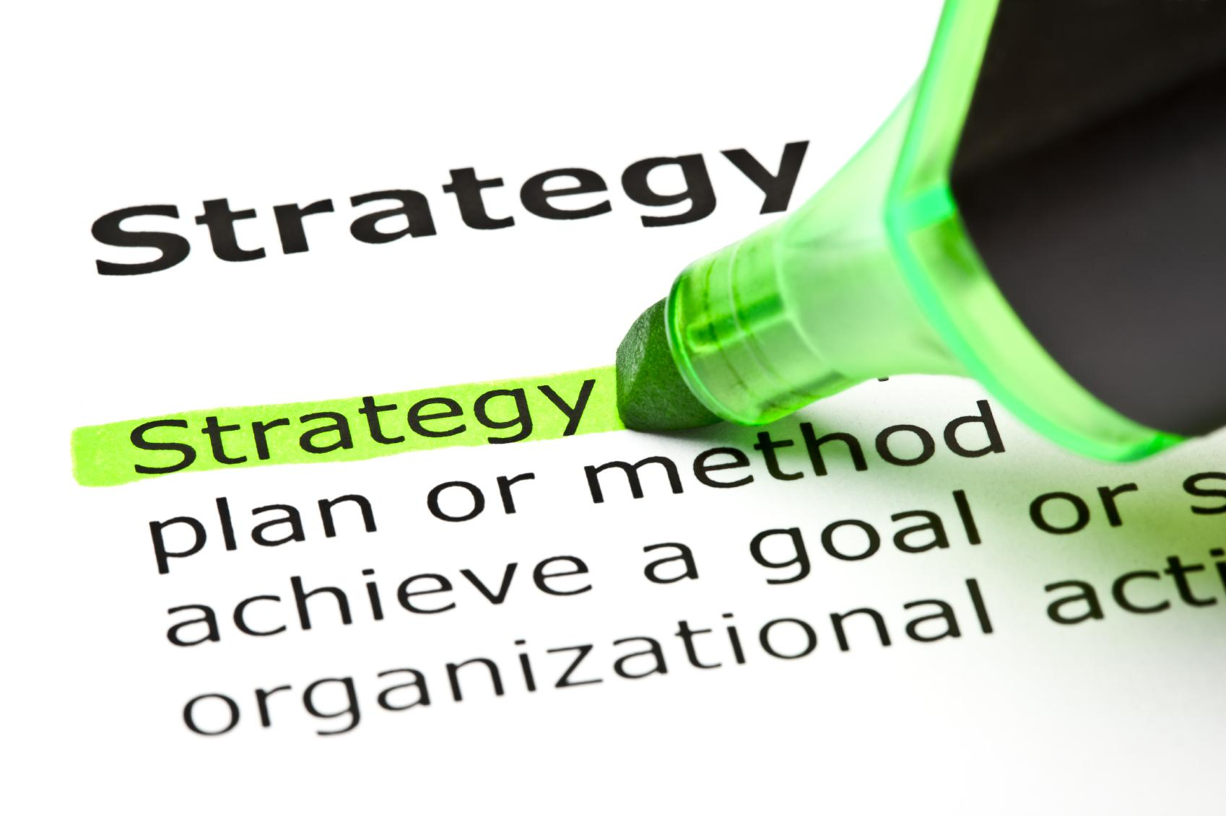
Purpose | To compare the use of the word “Strategy’ in different fields.
Task | Find five (5) different definitions of Strategy, specify their field of origin, select one and briefly justify your choice.Upload the result of your research in the following wiki (link) before September 15th 2015.
Reflexion & feedback | You must come prepared to class as there will be an in-depth discussion. What differences do you identify between disciplines? Comment points.
Resources | The word strategy is used in a variety of fields (military, marketing, organizational behavior,etc.). Explore the school library, LOR and external database as well as relevant sites (BCG, McKinsey, Harvard Business School, strategy professors, etc.) to find your five definitions.

First impressions

Is it clear what you are supposed to do? Describe any issues

List two of the features of the activity you found enjoyable and/or effective

How would you improve the activity?

Overall comments

 | e2: Prepare F2F session #2
Purpose | To become familiar with the key concepts used in the external strategic diagnosis of a company (industry definition, segmentation, attractiveness and life cycle)
Task | Take Session 2 quiz.  In order to prepare for the quiz you need to read: “What is strategy ?” (article); Grant 1, 3 and 4 (segmentation analysis part only) and/or listen to attached videos. (4 hours)
Reflexion and feedback | On the basis of the quiz and the results you obtained, you might have difficulties with some of the questions. List your concerns  questions and/or comments so we can address together in class.
Resources | The above resources are on the school LMS and Learning Hub.

Grading: Pass or Fail  (Fail -> -1 point on the SDD project) | p2: The SDD project - step 1 (Industry attractiveness)
Purpose | Apply the tools and concepts seen in session 2 to a real company and determine industry attractiveness. Identify the industry in which your company compete, segment it and assess its attractiveness.
Task | Write a two-page report and upload it before XXXX/2015.  Sub-task 1: Identify the data you will need to apply the various concepts and tools and find it using various reliable sources of business information (Thompson, Xerfi, annual reports, corporate websites, strategic analysts (ODDO), etc.  Sub-task 2: Apply the methods and tools seen during session 2.  (Based on a team of five, each student can expect to work 4 hours).
Reflexion and feedback | List your concerns and/or comments so we can address together in class.
Resources | Consult learning hub (Read Note on best business information sources.

 | e6 - POWER
Purpose | To apply the power framework to a case-study
Task | In groups  Prepare 1 slide on the sociogram of the situation  Prepare 1 slide on the diagnosis of the case using the analysis grid (found in the session reading)  Prepare 1 slide on recommendations to implement the proposed change  Post your analysis on the VLS
Reflexion & feedback
Resources

 | e1 : Video Debrief and Comparison
Purpose | Understand the variety of problems that a company can encounter during the company lifecycle from birth to death
Task | Participants watch the feature film “Startup.com” online that presents the story of a real company’s journey from bith to death.  Then as a team you are asked to post your response to the 3 questions into the course forum.  1. What were 5 critical mistakes made by the startup through its lifecycle (birth to death)? Explain your reasoning. (500 words max)  2. What 2 things would you have done differently and how? (200 words max)  3. In what way did the company grow and how would you measure this? (100 words max)  You and your team CAN’T see (parameterized) the other teams’ answers until they submit their own.  After you have submitted answers (a fixed deadline is imposed by the VLE) the teams complete a “similarities/differences” analysis sheet (word) and submit via a dated dropbox.
Reflexion & feedback | In the session each team presents their analysis (2”) and a short discussion ensues.
Resources | Youtube video  Online Forms

Calculated risk - Silverjet

Richard Farleigh explains why people are sometimes more important than product when it comes to investing in start-up businesses and early ventures.

 | e2 : “Fortune or Fizzle” ?
Purpose | To test your capacity to defend a decision concerning a growth opportunity and see how investment professionals define a business opportunity.
Task | Inside the VLE, all participants are provided with three videos of new venture presentations that want to grow growing. The videos shows the entrepreneur (or team) explaining why you (as a potential investor) should invest in the venture’s growth strategy.  At the end of each video you are asked to say YES or NO, if you would invest AND to give a short justification (50 words max).  In teams, you are asked to define an “opportunity detection grid” that defines 6 criteria that hels distinguish a “real opportunity” from a “flop”. You must define each criteria and how it is measured. You must also find ONE company/idea (using the internet) that failed that would also NOT pass their grid’s “litmus” test.
Reflexion & feedback | In face-to-face, each team presents their grid in a 2” presentation.  Have investor/entreprenur  - flow chart  - Too much ???  - D2L break into parts  A final video is presented in class and the real entrepreneur concerned takes Q&A from the audience. The real entrepreneur evaluates the 2” presentations of each team and their proposed criteria (summative assessment) and evaluation of grid’s strengths weaknesses
Resources | WEF Lion’s den videos (property of EMLYON)  or Youtube videos from Dragon’s Den

 | e3 : Peer defined formative quizzes
Purpose | Advance understanding of course objectives by creating and using formative quizzes every week.
Task | Every week, a team is assigned to build a 10 question multiple choice quiz and submit to the professor.  Quizzes linked to learning objectives.  The professor uploads the quiz to the VLE and participants are given the chance to take the quiz and give feedback on the quiz (difficulty, worthwhile,pertinence,...)  give explanation of a GOOD question. Expect at least 50% good response, usefulness, etc.  The quality of the quiz will enter into the summative evaluation of the team.  Lastly, the FINAL multiple choice test (summative) will draw on a subset of the best questions
Reflexion & feedback | Feedback from peers and professor
Resources | online quiz creation tool with word based format

 | e4 : Reflection
Purpose | Encourage participants to reflect on their personal development on a contuous basis.
Task | A personal reflection grid that covers the “key competencies” of the course is provided in the VLE for each week.  The form is connected to the “items” in the e-portfoloio. The participant may request the faculty advisor to give comments into the eportfolio.
Reflexion & feedback | Potential 360 feedback
Resources | online VLE form linked to eportfolio and “key outcomes”.

